REVERSE STRING
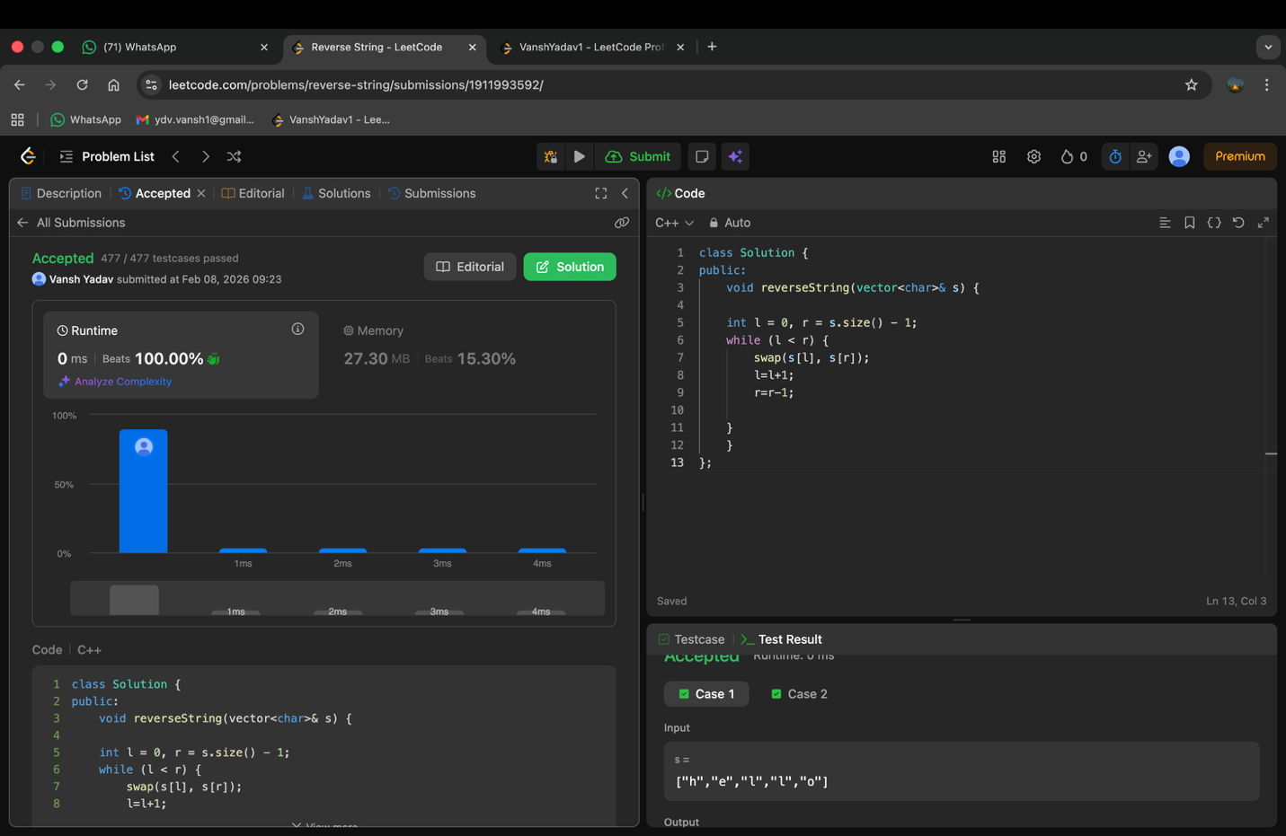

ANAGRAM 1 case not passed
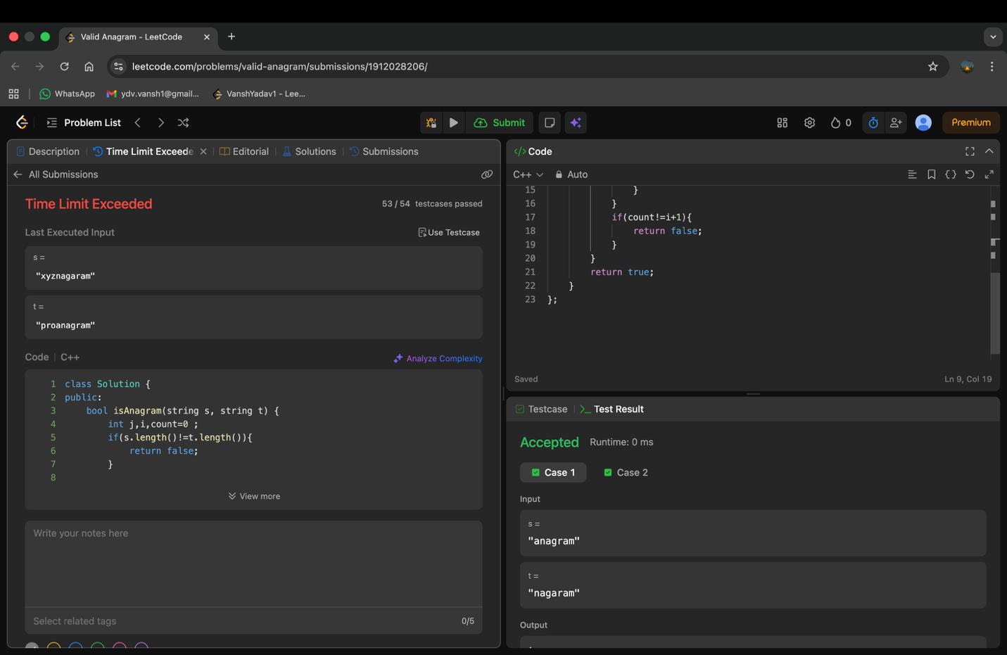

VALID PALINDROME(memory limit exceeded can’t understand) 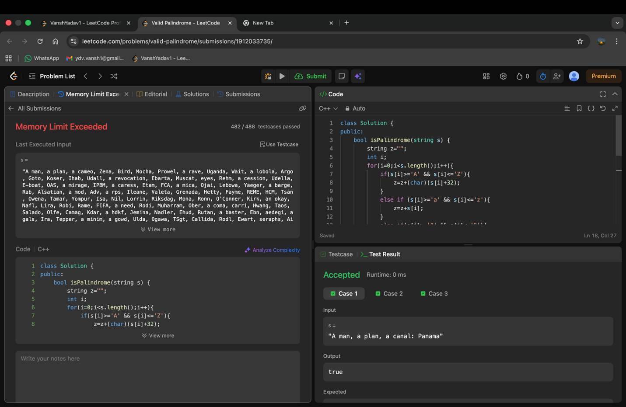

PALINDROME NUMBER
